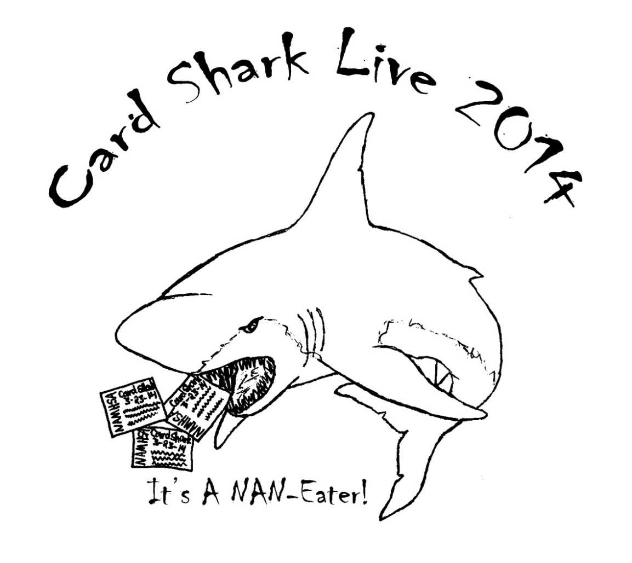
Date: March 23, 2014
Show Site: University Church
212 SW 4th College Place, WA 99324
Host: Bethany Shaw
Email: rebelsbutterfly@hotmail.com
Phone: 541-861-0587
Website: http://cardsharklive2014.weebly.com

Card Shark Live 2014 Entry Form

Mail Entries to: Personal Check and PayPal accepted
Bethany Shaw
53184 Lewis Lane
Milton-Freewater, OR
97862

Name: __________________________________________________________________
Address: __________________________________________________________________
City, State, Zip:______________________________________________________
Email:_____________________________________________________________
Region 1 Tag Number:_____________________
I’d like my table near (I’ll do my best to accommodate):__________________________________
Donation of a raffle item is required for this show and I am aware I must present it when I arrive the morning of the show or send it ahead: ________(initial) (no minimum value is required, but in order to keep show costs low, please bring something fun that you think people would enjoy!)
Entry Deadline: Friday, March 7th

Unlimited Entry |  | $25.00
PayPal Fee (if paying with PayPal) |  | $2.00
Per Model Fee (Limit 6) |  | $5.00
Late Entry Fee-Unlimited entry (after March 7th, 2014) |  | $30.00
Proxy Entry –proxy-shower will be: |  | $15.00
Entry on Show Day (if space permits!) |  | $30.00
Sales Table or Extra Table |  | $20.00
Show Program Business Card Ad |  | $3.00
Show Program One Half Page Ad |  | $5.00
Show Program Full Page Ad |  | $10.00
 |  |  | TOTAL

I will be participating in the following divisions (this just helps me to get an idea of where everyone will be showing):
______________________________________________________________________
______________________________________________________________________
______________________________________________________________________

DONATIONS: I plan to donate the following item(s): do not have to have a description prior to show day, but it’s helpful to plan and ideal that I can put a photo on the website!
________________________________________________________________

I hereby release Bethany Shaw, the event coordinators, judges, helpers for Card Shark Live, and all employees of the University Church, as well as the facility management, of any liability for any personal injury, property damage or loss that may occur during the course of this event. I further understand that all judges' decisions are final, and I agree not to hold any judge or member of the event staff liable for any decision or judgment that is made in the course of the event. I have read and understood the rules of Card Shark Live and agree to abide by these rules. I understand that if these rules are violated, I may be asked to leave the class or event at any time with no refund of fees.
Signature: __________________________________________ Date: ________________

Parent/Guardian: ____________________________________ Date: ________________

Please submit a list of horses entered on or before the show day. Additions/ Changes may be made the morning of the show. See the show Director or Secretary the morning of the show.

Class List:

Five Divisions with multiple classes

*Classes may be split/combined at judge’s discretion*

OF Breyer/Other Plastic

Traditional/Classic Scales
Judge:
Sport Breeds
1. TB/STB
2. European WB
3. All other WB/Sporthorses
4. Carriage (Fresians, etc)
5. Other pure/part sport
6. Sport Breed Foals
Sport Breed Championship
Light breeds
7. Arabian
8. Part-Arab/NSH
9. ASB/TWH/MFT
10. Paso Fino/Peruvian Paso
11. Other Pure Spanish
12. Morgan
13. Other pure/part light
14. Light Breed Foals
Light breed Championship

Draft breeds
15. Clydesdale/Shire
16. Belgian/Percheron/similar
17. Other pure part/mix
18. Draft breed foals
Draft Championship
Pony Breeds
19. Heavy/Stock type (British) pony
20. Light/Sport type (Welsh, Am. Shetland) Pony
21. Other pure/part Pony
22. Pony breed foal
Pony Championship
Stock breeds
23. Quarter Horse
24. Appaloosa
25. Paint
26. Mustang
27. Other pure/part stock
28. Stock breed foals
Stock Championship

Other Equine
29. Mule
30. Donkey
31. Zebra/Exotic/Other
32. Exotic/Longear/Other foals
Exotic Championship
OF Collectability*
33. Breyer OOAK or Test Run
34. Connoisseur
35. Breyer special run of 2-500
36. Breyer special run of 501+
37. Regular Run
38. All decorator (ex: charcoal, woodgrain, gold charm etc)
39. All unrealistic (pinks, patterns, holiday & halloween etc)
40. Other plastics collectability (Schleich, etc)
Collectability Championship
Overall OF Large Halter Championship

OF STONE

Traditional Scales
Judge:
Sport Breeds
1. TB/STB
2. European WB
3. All other WB/Sporthorses
4. Other pure/part sport
5. Sport Breed Foals
Sport Breed Championship
Light breeds
6. Arabian
7. Part-Arab/NSH
8. All Gaited
9. All Spanish
10. Morgan
11. Other pure/part light
12. Light Breed Foals
Light breed Championship
Stock breeds
13. Quarter Horse
14. Appaloosa
15. Paint
16. Mustang
17. Other pure/part stock
18. Stock breed foals
Stock Championship
Draft/Pony/Other Equine breeds
19. Clydesdale/Shire
20. Belgian/Percheron/similar
21. All Spotted Drafts
22. Other pure part Draft
23. Heavy/Stock type (British) pony
24. Light/Sport type (Welsh, Am. Shetland) Pony
25. Other pure/part Pony
26. Mule / Donkey / Exotic (incl. foals)
27. Draft/Pony breed foals
Draft/Pony/Other Equine Championship
Stone Collectability*
28. All unrealistic/decorator
29. YCI/Artisan Hall/OOAK
30. Run of up to 30
31. Run of 31-100
32. Run of 100+
33. Regular Run/DAH
Collectability Championship
Overall OF Traditional Halter Championship

OF Breyer/Other Plastic MINI

Bit/Pebbles, Stablemate/Chips & Micro Mini Scale
Judge:
Sport Breeds
1. TB/STB
2. European WB
3. All other WB/Sporthorses
4. Carriage (Fresians, etc)
5. Other pure/part sport
6. Sport Breed Foals
Sport Breed Championship
Light breeds
7. Arabian - Breyer/Other
8. Arabian - Stone
9. Part-Arabian - Breyer/Other
10. Part-Arabian - Stone
11. NSH
12. ASB
13. TWH
14. Spanish Breeds - Gaited
15. Spanish Breeds - Non Gaited
16. Morgan
17. Other pure/part light
18. Light Breed Foals
Light breed Championship
Draft breeds
19. Clydesdale/Shire - Breyer/Other
20. Clydesdale/Shire - Stone
21. Belgian/Percheron/similar
22. Other pure part/mix
23. Draft breed foals
Draft/Long-ears Championship
Pony Breeds
24. Heavy/Stock type (British) pony
25. Light/Sport type (Welsh, Am. Shetland) Pony
26. Other pure/part Pony
27. Pony breed foal
Pony Championship
Stock breeds
28. Quarter Horse
29. Appaloosa
30. Paint
31. Mustang
32. Other pure/part stock
33. Stock breed foals - Colored
34. Stock breed foals - Solid
Stock Championship
Long-ears/Other Equine
35. Donkey
36. Mule
37. Other Equine
38. Other Foals
Longears/Other Championship

OF Mini Collectability*
39. OOAK/YCI/Artisan Hall (Stone)
40. Run of 50 or less (Stone)
41. Run of 50+ (Stone)
42. Connoisseur (Breyer)
43. SR Realistic G1-G2 (Breyer)
44. SR Realistic G3-G4 (Breyer)
45. Regular Run/DAH
46. All decorators & unrealistic colors
47. Other plastics collectability (Schleich, etc)
Collectability Championship
Overall OF Small Halter Championship

Artist Resin

All scales
Judge: Shana Bobbitt
Sport Breeds
1. TB/STB
2. European WB
3. All other WB/Sporthorses
4. Carriage (Fresians, etc)
5. Other pure/part sport
6. Sport breed foal
Sport Breed Championship
Light breeds
7. Arabian
8. Part-Arab/NSH
9. All Gaited Breeds
10. All Spanish Breeds
11. Morgan
12. Other pure/part light
13. Light breed foal
Light breed Championship
Draft breeds
14. Clydesdale/Shire
15. Belgian/Percheron
16. Spotted Draft
17. Other pure part Draft
18. Draft breed foal
Draft Championship
Pony Breeds
19. Heavy/Stock type (British) pony
20. Light/Sport type (Welsh, Am. Shetland) Pony
21. Other pure/part Pony
22. Pony breed foal
Pony Championship
Stock breeds
23. Quarter Horse
24. Appaloosa
25. Paint
26. Mustang
27. Other pure/part stock
28. Stock breed foal
Stock Championship
Other Equine
29. Mule/Donkey
30. Zebra/Exotic
31. Other pure part exotic.
32. Exotic/Longear/Other foals
Exotic Championship
Workmanship
33. Bay/Brown
34. Black
35. Chestnut
36. Dilutes
37. Appaloosa pattern
38. All pinto pattern
39. Grey/roans
40. Unrealistic
41. Other (ex: zebra pattern)
Workmanship Championship
Overall AR Championships

Customized

Any scale
Judge:
Sport Breeds
1. TB/STB
2. European WB
3. All other WB/Sporthorses
4. Carriage (Fresians, etc)
5. Other pure/part sport
6. Sport breed foal
Sport Breed Championship
Light breeds
7. Arabian
8. Part-Arab/NSH
9. All Gaited Breeds
10. All Spanish Breeds
11. Morgan
12. Other pure/part light
13. Light breed foal
Light breed Championship
Draft breeds
14. Clydesdale/Shire
15. Belgian/Percheron
16. Spotted Draft
17. Other pure part Draft
18. Draft breed foal
Draft Championship
Pony Breeds
19. Heavy/Stock type (British) pony
20. Light/Sport type (Welsh, Am. Shetland) Pony
21. Other pure/part Pony
22. Pony breed foal
Pony Championship
Stock breeds
23. Quarter Horse
24. Appaloosa
25. Paint
26. Mustang
27. Other pure/part stock
28. Stock breed foal
Stock Championship
Other Equine
29. Mule/Donkey
30. Zebra/Exotic
31. Other pure part exotic.
32. Exotic/Longear/Other foals
Exotic Championship
Workmanship
33. Bay/Brown
34. Black
35. Chestnut
36. Dilutes
37. Appaloosa pattern
38. All pinto pattern
39. Grey/roans
40. Unrealistic
41. Other (ex: zebra pattern)
Workmanship Championship
Overall Custom Championships

**Fantasy OF and Fantasy CM will be held at lunch break

These are now NAN qualifying for equines with horns/wings.

Rules/Info:

Hours:
Set up begins at 7 AM
Judging will begin at 8 AM
Location:
Walla Walla University Church (basement)
212 SW 4th Street, College Place, WA
The church is on the Walla Walla University Campus and is next door to the Canaday Technology Center. From 4th street there is a rectangular parking lot that is shared with the Canaday Tech. Ctr. This is where you will want to park, as the door we are using is off of that lot. There is a half flight of stairs down to the basement, make a left when you see the bathrooms and drinking fountain, go through the double doors and you will be there. The room is 80 1/2' long and 42.5' wide with 39 six-foot tables for entrants and 8-foot tables for the judging.
Eligibility: This show is open for anyone to enter. There is no membership required. As per NAMHSA rules, the show holder and anyone in their immediate family may not enter the show. A judge who customized or sculpted a model shall not judge that model in any class. Judges shall not complete in any divisions that they are judging.
Space: We will have space for 39 entrants. Each shower will be assigned a 6' table. Please plan accordingly. Don't wait to send in your entry! Additional tables are $20.
Divisions:
OF Breyer/Other Plastics -- any Breyer or other plastic model that is in original factory condition, in Traditional (1:9) or Classic (1:12) scale.
OF Stone -- any Stone model that is in original factory condition, in 1:9 or 1:12 scale.
OF Plastic Mini -- any Breyer, Stone, or other plastic model that is in original factory condition, in Little Bit/Pebbles (1:24), Stablemate/Chips (1:32), or Mini Whinny (1:64) scale.
Artist Resins -- all Artist Resin.
Customized -- any plastic make of model horse that has been customized in any way.
*Newly NAN-eligbile FANTASY equines will be judged during the lunch hour! There will be one OF and one CM class.

Judging:
Please give the judges their space! Ask any questions before the class or the show. All of the judges' decisions are final. Classes may be split or combined. No unsportsmanlike behavior will be tolerated.

Judging criteria :
Breed Classes - Conformation, Breed Standards, Condition/Workmanship
Collectability - Rarity, Age, Condition, Desirability/Value
Workmanship - Prepping/Sculpting Quality, Detail, Paint/Finish Work
Judges will be allowed to use breed books at their discretion to assist in placing horses in the correct breed class.
Judges are allowed to show models in divisions that they are not judging.
Halters are not required in halter classes, but an improper or ill-fitting halter may be detrimental to the entrants placing.
Foals may only enter in foal classes & may NOT cross enter in open breed classes.
Foals may enter collectability and workmanship classes.
Entry Limit:There is no entry limit per shower but there will be a 4 horse limit per halter classes. A 3 horse limit on performance classes. Please bring an ascending list of your models on the day of the show. Include model's tag number, name, breed, and finish. We will be using the Region 1 tag saver program. (See below for more info) If you wish to show more than the limit of horses, please plan to pay $1 for each additional horse per class. Simple place $1 next to each over-limit horse on the table.
Leg Tags:Each shower must provide their own legs tags & must provide a model list the day of the show. I would advise you check out the Region 1 tag saver program and get signed up with a number (it is free) Tag Program: http://region1tagnumbers.webs.com/
Each entrant that does not currently have a Region 1 tag saver number will be assigned a temporary shower number. Please let the show holder know if you are in need of a shower number. Leg Tags should include the shower number, specific model #, and model breed assignment. For example: shower code=S, model #=1, breed=Shire
S-1
Shire
Please print neatly so that judges may clearly read each tag.
Lunch: We will break around noon for lunch for 45-60 minutes regardless of where we are in the classes. Lunch will be provided for judges by TBA.
Awards: Classes will be placed 1st-6th. NAN cards will be awarded for 1st-2nd place equines. Laminated place markers will indicate 3rd-6th place. Recycled ribbons are welcome and will be available at the show until they run out! Recycled rosettes will be awarded to Grand/Reserve if donations allow. IF YOU HAVE ANY RIBBONS/ROSETTES TO DONATE, THEY WOULD BE APPRECIATED!!
Results: results will be provided either via email or mailed. Entrants requesting mailed results will need to provide an SASE by show day.
NAMHSA Member show: All equines that place either 1st or 2nd in their class will be awarded a NAN card that will be good for NAN in 2014 -2017. Any equine that wins a NAN card may enter at NAN. For more information on this, please see their website at www.namhsa.org.
Classes: All classes will be called simultaneously on separate tables. Table markers will indicate what table models should be placed on. Showers are responsible for getting their models on the table in a timely manner.
Raffle: Donation of a raffle item is required with entry for this show to help keep show costs down. Any and all donations are welcome. Donors of raffle items valued at $10 and up will get an advertisement in the show program (if I’m notified before show day) and a thank you on the website. Raffle tickets will be available for purchase on show day for $1 each, or 6 for $5.
Advertising: To advertise in the show program, please see the price list on the entry form. Contact rebelsbutterfly@hotmail.com to be listed. Ad must be copy ready. Show program will be printed in black & white so keep this in mind when submitting an ad for the program.

Entry deadline: March 7th, 2013. Entries will be taken day-of-show for an additional $5 fee.
ENTRY INFORMATION:
- No fee/entry sharing is allowed. Everyone must personally own the models they are exhibiting, unless they are being proxy shown.
- Proxy entries must clearly mark their entry form as a Proxy Entry and the entry will not be allocated table space (this shall be the responsibility of the proxy shower unless other arrangements are made).
- The Refund Policy is as follows: All requests for refunds must be made in writing at least 7 days prior to the show. Refunds will ONLY be made for extenuating circumstances.
- Please note: There will be a $55 charge for any checks returned for insufficient funds (bank fee plus $10).
Selling: Selling is allowed at show tables.
Proxy Showing: Proxy Showers are welcome & must follow entry rules. Please state on your entry who will be proxy showing your models.
Animals: No animals are allowed unless they are service animals, such as seeing eye dogs.
Children: Model shows are not a place for unattended children. Each shower knows if their children are able to be at the show. Please be considerate of others and keep in mind the liability risks.

Accomodations:
Walla Walla University campus has rooms available in the Foreman Hall dorm for $45/night.  There are two traditional twin beds per room. Showers/restrooms are on one floor for the women and another for the men. The main guest rooms include soaps, towels, mini-fridge and made up beds.  Link to request a reservation:  Pay upon checking in… credit card, check or cash.  * * *  Holiday Inn Express and  Comfort Inn & Suites  are within 2 miles of the show site.  Holiday Inn Express  ‎1433 W Pine Street  Walla Walla, WA 99362  (509) 525-6200  Comfort Inn & Suites  1419 West Pine Street  Walla Walla, WA 99362  (509) 522-3500  Google for more options. | Other Hotels  La Quinta Inn Walla Walla  ‎520 North 2nd Ave  Walla Walla, WA 99362  (509) 525-2522  Walla Walla Vineyard Inn  ‎325 East Main Street  Walla Walla, WA 99362  (509) 529-4360  Travelodge Walla Walla‎  421 East Main Street  Walla Walla, WA 99362  (509) 529-4940  Hampton Inn & Suites Walla Walla‎  1531 Kelley Place  Walla Walla, WA 99362-8654  (509) 525-1398
Fast Food
Downtown on 9th Street we have the following food options:
McDonalds
Jack In The Box
The Iceburg (burgers)
Taco Bell
Fast Eddys (burgers)
There is also a Shari's (American), Thai Ploy (Thai), Golden Horse (Chinese), and Taqueria Yungapeti, Rositas & LaCasita (Mexican) for dinner options on 9th.
Other options in other parts of town, ask me if there is something specific you'd like.

